THE MINI

MAKERSPACE



**Report #2**

**Product Design & Development**

**Spring 2021**

Stephanie Smolinski

Felipe Quintella

Rosalie Phillips

Ryan Poon

Arjun Shah

Luke Higgins

Nicholas Borge

Haroon Waseem

Nick Cholst

# Table of Contents

**Table of Contents** **1**

**Mission Statement** **2**

**Customer Needs** **2**

**Target Customers** **3**

**Concept Description and Core Benefits** **3**

**Detailed Design** **4**

**Product Specifications and Testing** **6**

**Sustainability Life-Cycle Analysis** **7**

**Manufacturability** **9**

**Patent Analysis** **10**

**Business Plan and Financial Analysis** **12**

**Next Steps** **15**

**Retrospective and Team Management** **16**

**Appendix A** **17**

**Appendix B** **20**

**Appendix C** **21**

**Appendix D** **22**

# Mission Statement

Our mission is to help hobbyists express their creativity from the comfort of their home using a robust, small-scale, and versatile workbench. We crafted this mission statement to carefully consider:

1. the **target audience** (hobbyists), which we refined and further defined through our customer segmentation and market analysis;
2. the **value** that they receive (expressing their creativity at home), which was synthesized from thinking through common themes in our exploration with customers;
3. the **means** by which to generate that value (a robust, small-scale and versatile workbench), with the key attributes prioritized from our needs analysis.

# Customer Needs

After the second sprint our team further researched customer needs through the use of tests and user feedback. The main needs have remained primarily the same with a few additions. We observed some latent needs by carefully studying our customers' use of the Mini Makerspace. For example, after attending a customer test session we noticed that the user rolled out the cabinet and used it as a seat right away, something that we had not planned on. However, it was overwhelmingly well received, so we added it to our customer needs list.

We delineated our market research participants into 4 groups: (1) hobbyists, (2) craft-product sellers (Etsy), (3) professional workers, (4) retired middle-aged men and women. We decided that these groups shared a common need that is covered by our main value-proposition, having a robust, yet presentable in-home workbench.

Our consumers’ needs remain split in 5 main categories: Durability, capacity or storage, versatility, aesthetics, and tidiness. An in-depth list of customer needs is in Table 1.

**Table 1.** Customer Needs and Importance Ranking

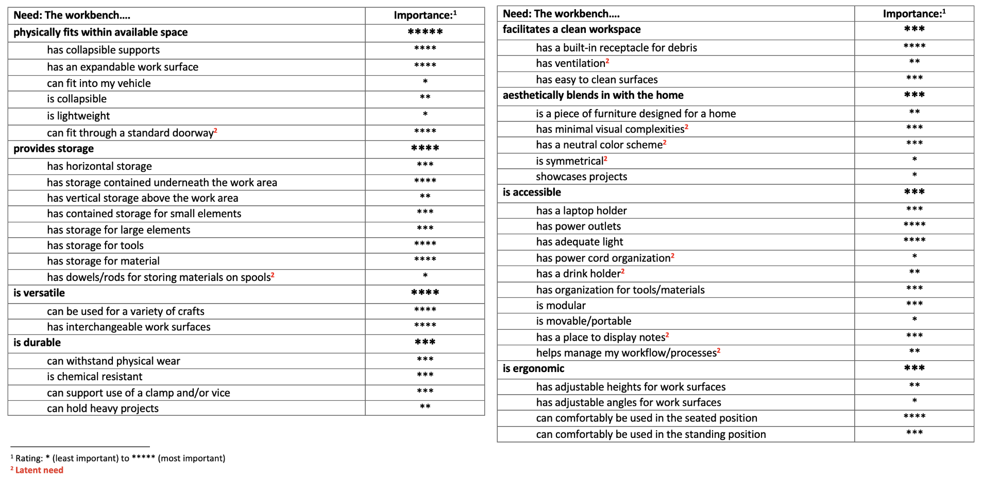

# Target Customers

As mentioned above, the team has identified 2 primary target groups:

* Mid to late 20s and early 30s, working and willing to pay for a quality product that fits their spatial requirements and enables their craft(s).
* Late 70s retired middle class men and women who want to fill their spare time and start a craft hobby while staying in the comfort of their home.

We decided that our primary market should be US makers working in small areas that do not currently have access to makerspaces. These people are mid 20 and older and are willing to pay for a quality product that fits their spatial requirements and enables their craft(s). We are aiming to fulfill multiple needs for the users so they can engage in multiple crafts--particularly electronics, hardware assembly, sewing, and post-processing woodworking and metalworking--but this is not completely necessary because we see versatility as a commonality between users.

A secondary market identified was schools where a maker space is desirable but where school budget and spatial limitations require the space to be in multi-purpose classrooms.

# Concept Description and Core Benefits

**Figure 1.** Conceptualized Sketch

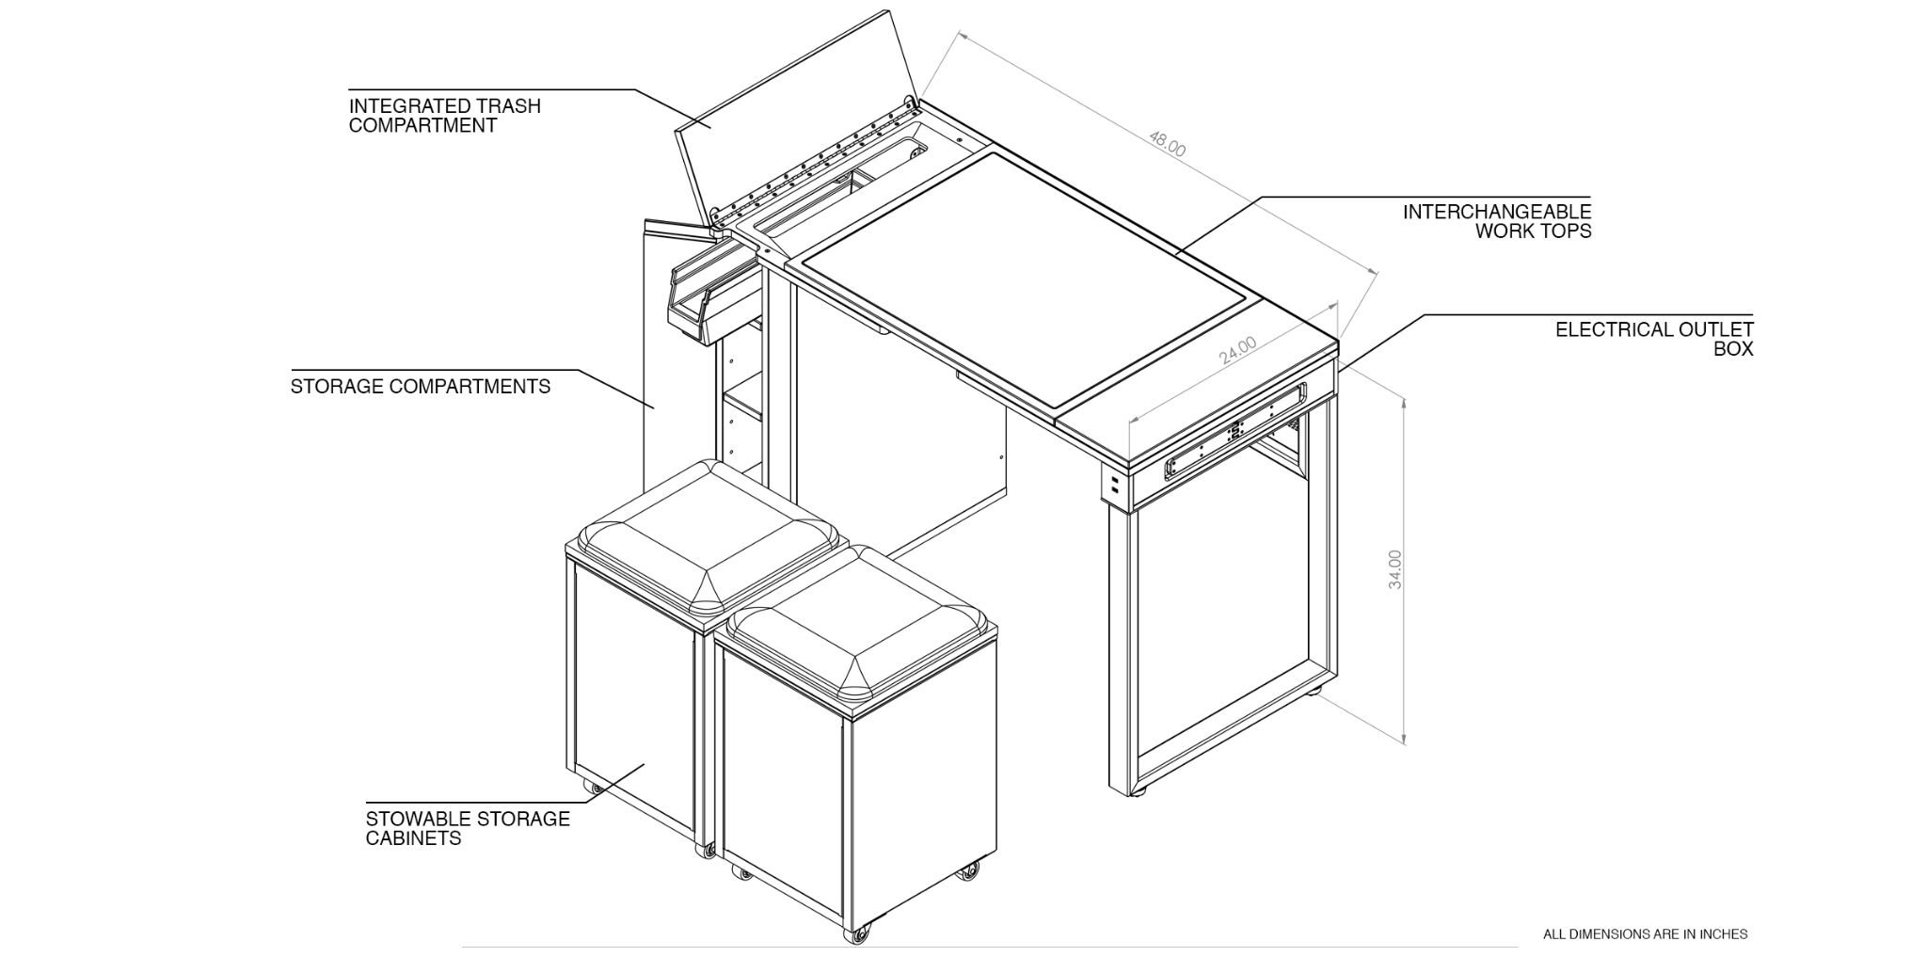

We set out to bring making to the apartments by bringing function and form together into a compact, stylish and versatile piece of furniture that blends seamlessly into your everyday living environment. The result is an undeniably novel take on creativity in the home, so you can bring your ideas to life, whenever inspiration strikes you.

We hope that the Mini Makerspace will keep makers making, and will open up the possibilities of crafting to everyone, on your terms, in your space. The Mini Makerspace core benefits can be summarized as:

1. It can be used for a wide variety of different maker activities
2. It is compact and aesthetically pleasing
3. It helps keep the maker space clean and tidy

And we achieve these with thoughtfully designed features that

* **Interchangeable worktops** with inlaid surfaces on each side, enabling cutting, woodworking, soldering and assembly
* **Stowable storage cabinets** that can be wheeled out, and double as stools
* An integrated **trash compartment**, allowing hassle-free sweeping of dust and debris
* Integrated **electrical outlets** to power hand tools and equipment
* **Classic, functional look** that blends into your living space
* **Robust construction** that has been rated to endure more than 500 lbs

# Detailed Design

After Sprint 2, armed with feedback from the user testing process of our initial working prototype, the team went back to the drawing board. We systematically compiled all the additional feedback and, utilizing the average score derived from each team member’s importance ranking, made strategic decisions about what to focus on, improve, and implement on the Alpha prototype given our limited time frame (Table 2).

We then took this prioritized list of feedback and further organized it by feature, such as the worktop, trash slot, cabinets, and desk frame. After that, we grouped the common themes, posed them as uncertainties, and developed a plan of action to address them (Table 3).

For our interchangeable surfaces, the main feedback centered on a re-evaluation of the both size of the interchangeable piece and that of the actual working surfaces. It was also widely mentioned that the placement and size of the finger slots were not optimal. We redesigned the entire table top to make the usable surface area larger and facilitate changes.

In the case of the trash slot, we noticed that the size of the slot was an important parameter that drove convenient use of the feature, but it was also a common opinion that our “hidden” design was functional and aesthetically pleasing. We increased the trash slot size and added a ramp that will help guide scraps and dust into the trash bin.

As for the expandable features, we decided after careful consideration that the instability it brought to our design was too big of a problem for us to develop the concept and further. The team decided to turn over to a rolling cabinet concept that could also double as stools or chairs, and still provide the necessary storage space for tools and materials.

The team used multi-voting processes and pugh matrices throughout the past sprints to come up with the best design possible. As an example, we iterated from a sliding drawer trash-bin with a complex hinge system towards a simple, efficient shelf. On the shelf we incorporated a commercially available plastic bin to collect waste which is hidden by a convenient full-height door.

**Table 2.** Example of Feedback Table after Sprint 2

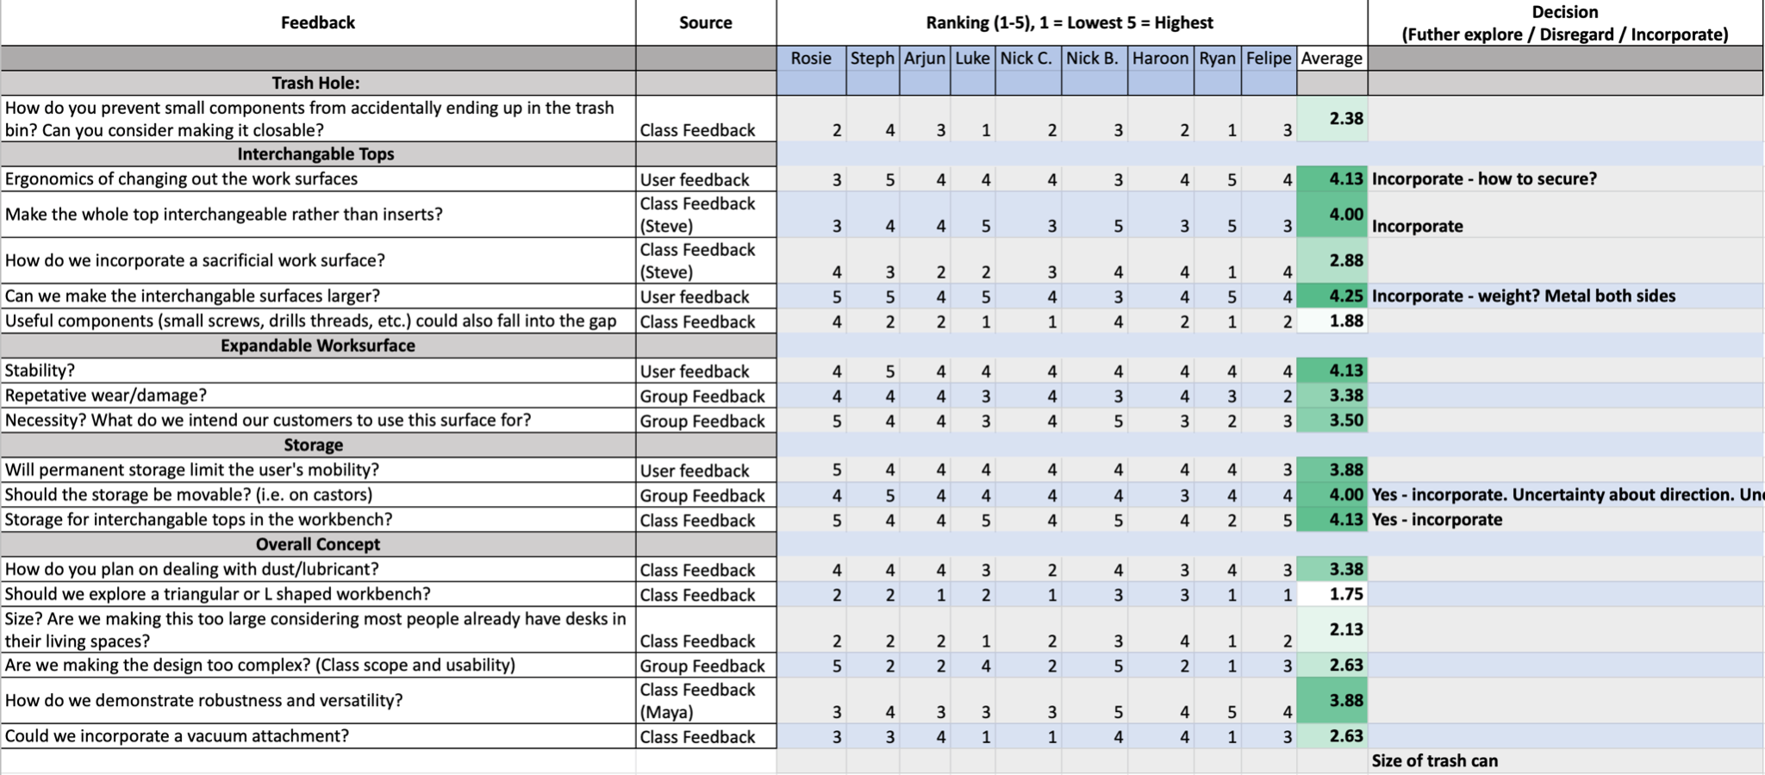

**Table 3.** Example of Uncertainties Derived from Sprint 3 and 4 Feedback

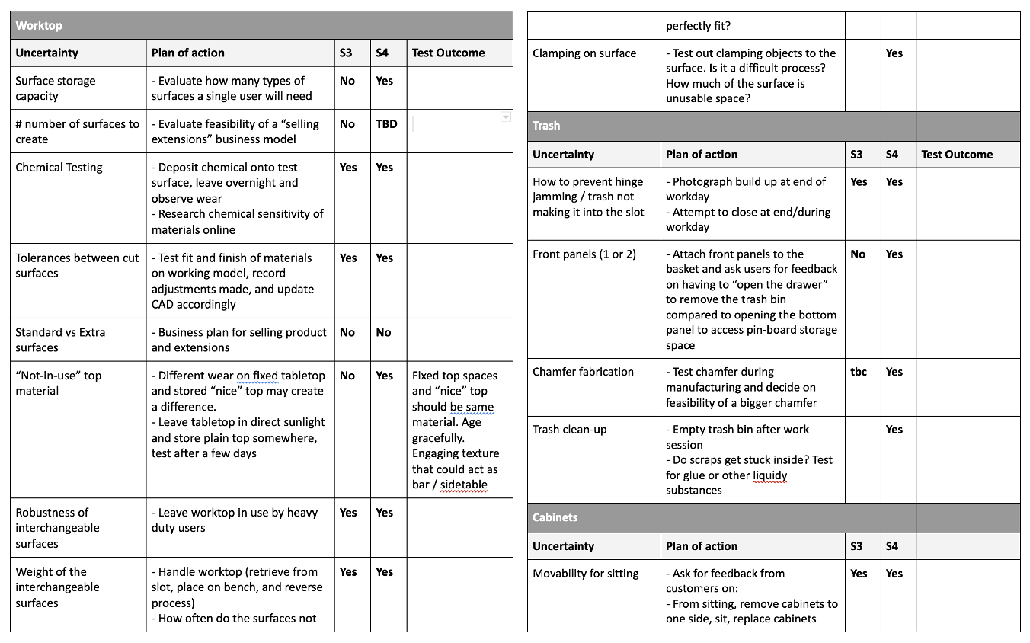

**Figure 2.** Alpha Prototype (Left), Final Design Concept (Right)

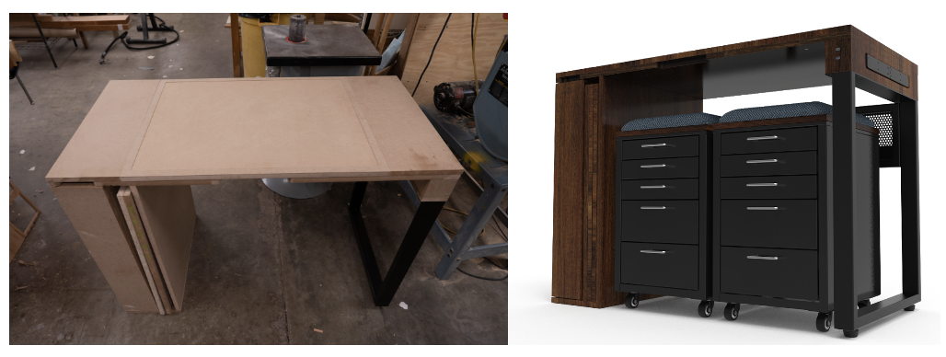

**Figure 3.** The Mini Makerspace Development Montage

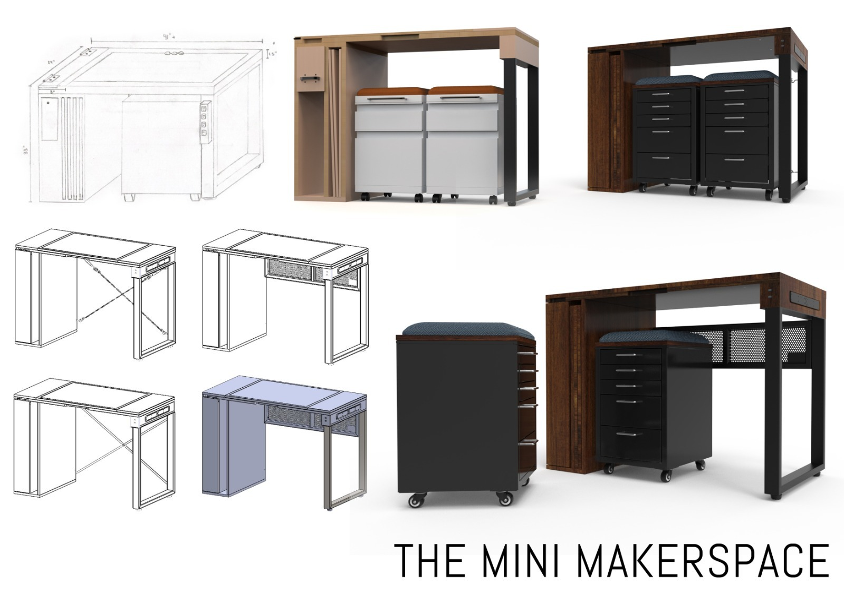

# Product Specifications and Testing

While throughout the feedback process our team identified additional needs, this did not change our original 5 highest ranking needs discovered during Sprint 1 and 2. Thus, the metrics we preliminarily used to represent these needs remained the same as well. Below you will see how our Alpha prototype compares when measured against these metrics (Table 4):

**Table 4.** Product Specifications

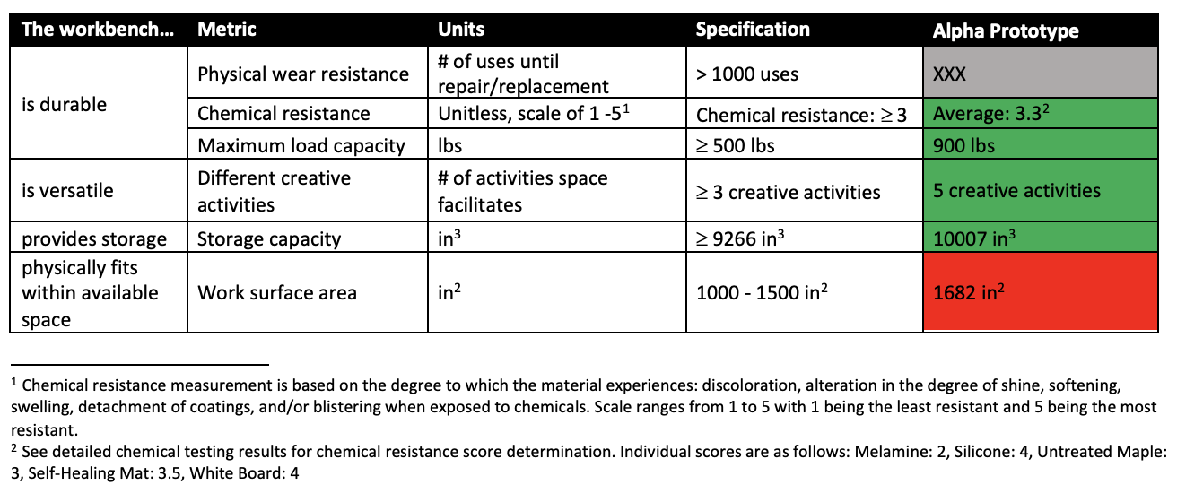

This data was obtained through a combination of numerical calculations and testing. For instance, storage capacity was obtained by calculating the volume of the rolling cabinets added to the storage shelves on the left leg. We also calculated the footprint of the desk in combination with the storage cabinets. While this is notably 182 in2 more than our specification, the team felt this was reasonable. When the storage cabinets are not in use, both can be pushed underneath the workbench reducing the footprint to just that of the workbench, 1,152 in2. The workbench also provides storage for two additional interchangeable tops, in addition to one top in-use, for a total of three. This means the workbench can facilitate five different surfaces, hence five different hobbies, with one top being decorative and designed to match the base material of the workbench. Notably, we were unable to observe 1,000 uses on the workbench, given time limitations. Listed below is an additional test (Appendix B) our team designed to assess the durability of our product:

**“Wear and Tear” Test:** Determine how repetitive use of the workbench and changing of the tops affects overall form, fit and function of the product. This test would repetitively perform a set of actions we anticipate a typical user to carry out.

The team also performed testing in order to determine if the designed product met the specification requirements. We conducted a Finite Element Analysis (Appendix D, Figure 10 and 11) of the workbench to ensure it met the maximum load capacity within required safety factors, and several chemical tests (Appendix A, Tables 5-9) to make sure the chosen surfaces would withstand common consumer use .

# Sustainability Life-Cycle Analysis

We conducted a sustainability analysis to compare preferred materials from which to manufacture our workbench and cabinets and inform our business model. Utilizing Sustainable Minds (SM), we modeled our workbench utilizing Medium-Density Fibreboard (MDF), with a lifetime of 5 years, and solid oak, with a lifetime of 8 years, with each concept having a functional use of 1 year. Within the functional 1-year use period, we assessed (1) the extraction of iron ore and wood from the Earth, (2) the production of steel tube, MDF and solid wood production, (3) post processing surface treatments, (4) packaging, (5) transportation, and (6) recycling, as well as all of the energy consumption associated with these processes, within a set of system boundaries (Figure 4). Consumption of craft supplies during the product’s useful life was not included in the analysis. It was not feasible to accurately estimate a user’s waste generation, and thus impact, due to the versatility of the workbench and associated variation of the users’ crafts, as well as the limitations of the SM software.

**Figure 4.** Life Cycle Assessment Diagram of the Workbench

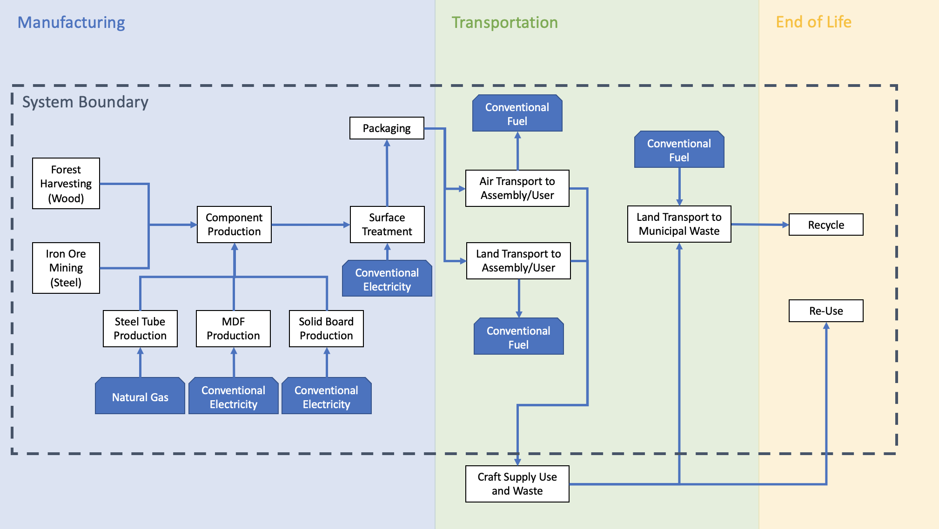

For our analysis we chose to compare the environmental impact of an economical material, like MDF, with a solid hardwood, like red oak. The SM software does not include an option for posttreatment of the wood or MDF, so this was a notable omission in the analysis. We feel it is reasonable and justified to assume a consumer would retain a solid wood piece of furniture longer than one constructed from MDF. We also utilized Sustainable Minds to estimate the minimum lifespan needed for our solid wood workbench in order for it to have a lower SM score per functional-use-year when compared to an MDF workbench. We discovered that retaining a solid wood workbench for 8 years results in a 7.6% performance improvement over an MDF workbench retained for 5 years (Figure 5). This information subsequently helped guide our continued design decisions, to ensure a solid oak workbench would be capable of lasting 8 years, and our business model assumptions.

We conducted a similar analysis for the construction of our cabinets by exploring low carbon steel, stainless steel and MDF, as well as the associated post processing techniques. Although unable to find a rolling cabinet with our desired dimensions and configuration, we selected three commercially available cabinets and reviewed their environmental impact. Ultimately, we found production of stainless steel to be extremely detrimental, and 780% worse than the low carbon steel IKEA cabinet (Figure 5). We then further explored MDF and low carbon steel from additional perspectives, such as strength, density and material cost. When considering these aspects collectively, we determined producing our cabinet out of low carbon steel would rank more favorably, although not the most sustainable.

**Figure 5.** Environmental Impact Comparisons of the Workbench and Cabinets

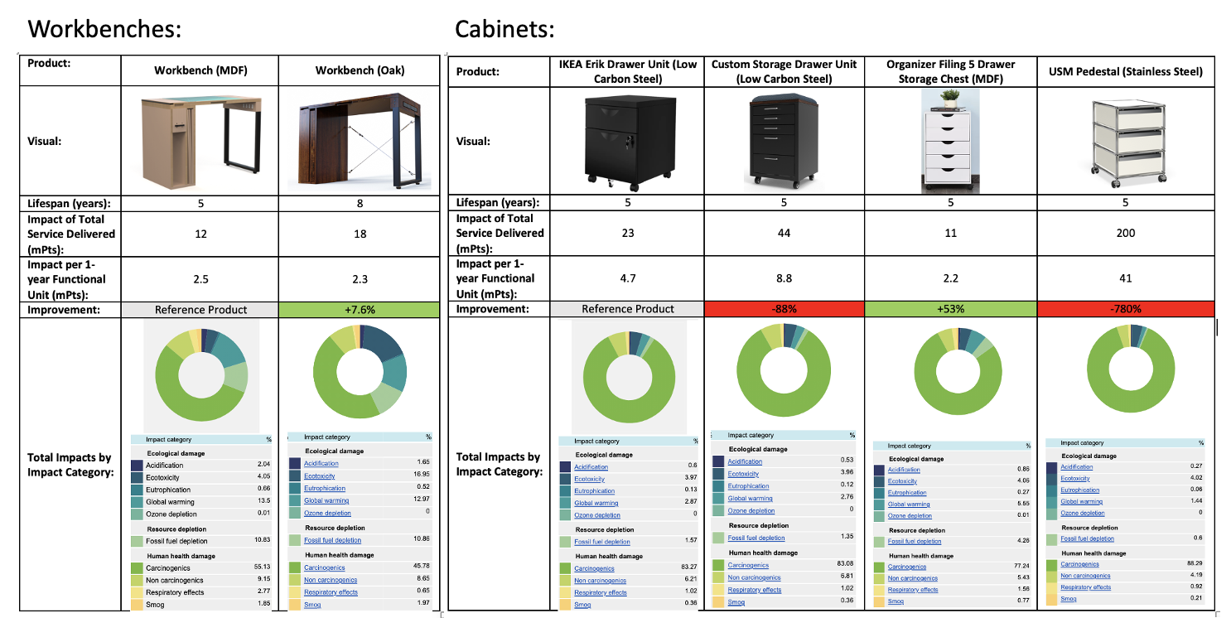

We anticipate most users will commercially recycle all materials associated with the construction of the workbench and cabinets at the end of their lifespans. As previously discussed, we do anticipate the materials used in conjunction with the workbench, including acrylic paints, solder, saw dust and metal shavings, will primarily end up in a landfill. This would ultimately increase the carbon footprint of the workbench over its entire lifespan. Given our users are makers and creators in general, we anticipate many will fix or adjust the bench on their own throughout its lifecycle, potentially leading to our workbench taking on a new life post its expected lifecycle.

# Manufacturability

Regardless of the material, the workbench is designed to require the fewest possible complex, time-intensive manufacturing processes (i.e. CNC routing). With the exception of the tabletop components, all the wood or MDF boards only require pilot or countersunk clearance holes normal to the edge or broad face of the board. The speed at which a commercial CNC machine is able to route the pockets and lofted cuts on the workbench top can be maximized using proper tooling, optimized toolpaths, and locator stop blocks. The workbench can also be flat-packed, removing the need for assembly at the production level and further expediting manufacturing time.

In terms of the wheeled cabinets (if manufactured and not off-the-shelf), the body is completely fabricated from bent laser-cut sheet steel to reduce the amount of hardware, manufacturing time, cost, and necessary equipment. However, the base needed to be fabricated from welded steel plates and rectangular tubes to uphold the structural integrity of the assembly. Like the workbench, the wheeled drawers can be flat packed, with the drawers arriving unfolded to the consumer, but having perforations along the “bend lines” allowing customers to bend them into place by hand. Handles, drawer slides, casters, and fasteners are from external vendors.

# Patent Analysis

Building upon our patent analysis conducted during Sprint 1 and 2, we wanted to narrow our focus on the interchangeable top, which we feel truly captures the innovation of our workbench. The base of the workbench top provides a recess in which to nest an appropriate work surface for the craft being performed. The inlay is open in the front, bordered laterally by the base material on two sides and a thin piece of steel as a barrier for the back. This design allows for the user to easily set an interchangeable worktop into the recess and slide it into place. To facilitate removal, there is a small notch on the front of the workbench top that allows the user to lift and take out the interchangeable top. When not in use, additional work tops can be vertically stored on the left side of the workbench.

The interchangeable tops are composed primarily of the same material as the workbench base. This provides a level of uniformity and an element of design integration. Additionally, the interchangeable tops are double sided in order to preserve storage capacity. Each side of the work top is uniquely designed to support a specific craft, or subset of crafts. These work surfaces are integrated and flush with the base material and could potentially include melamine, silicone, whiteboard, or a sacrificial MDF.

By developing this detailed description, we were able to conduct a more in-depth search into existing patents. However, we were still unable to find prior art that covered a workbench with an interchangeable top system. Below are two patents we felt were the most relevant to our product, including one for our original inspiration, interchangeable cutting boards:

US007036809B1 | Cutting Board Holder | William F. Mitchell | 2006

|  |  |
| --- | --- |
|  | **Abstract:**  “A cutting board kit having a cutting board holder capable of receiving two or more cutting boards. The cutting boards may be designated for use with specific classes of food products.” [1]  **Analysis:**  Although for an entirely different purpose, the functionality of inserting and using different cutting boards is similar to our workbench. Our objective would be to differentiate our workbench along (1) the ability to flip the work tops and (2) the ability for one surface to have the same material as the base of the workbench (“disguising” the working surface). |

USA105722473 | Workbench-based interchangeable power tool

mounting and operating apparatus | [Joseph M. Tucker](https://patents.google.com/?inventor=Joseph+M.+Tucker) | 1998

|  |  |
| --- | --- |
|  | **Abstract:**  “A workbench-based interchangeable power tool mounting and operating apparatus includes a workbench frame including a base supported on an upper portion of the frame, at least one main support pallet for mounting an electrically powered tool thereon...and a pair of alignment members mounted on the base for receiving and supporting the main support pallet on the base and slidably guiding the main support pallet into and from an installed position on the upper base of the workbench frame…”[2]  **Analysis:**  This design aims to provide versatility for working with different power tools. A key feature is ability to provide electricity to the tools being utilized. This is not intended to be used within the home or for the types of crafts intended for our workbench. |

The team also met with a patent lawyer, Bruce Sunstein, and based on our discussion it seems that the interchangeable worktop feature is patentable. Through our discussion with him, we believe that the product offers:

* **Novelty:** embodied primarily by two things (1) the interchangeable top feature and (2) its ability to blend within the home. As noted above, the tops are dimensionally uniform and double sided, with each side designed for a different activity. Additionally, we include a “decorative” top matching the base workbench material for aesthetic appeal.
* **Utility:** our workbench is both functional and aesthetic enabling it to be a permanent fixture in the home, and double as an aesthetically pleasing and contemporary piece of furniture, which wasn’t previously attractive to most apartment dwellers.
* **Non-obviousness:** the concept of an interchangeable top has been patented, as described in the examples above. What is non-obvious, however, is the ability to flip the double sided tops and having one surface serve as a decorative feature.

# Business Plan and Financial Analysis

Market Size (see Appendix C for more information)

We estimate the total addressable market size (defined as the total potential universe of consumers) for the Mini MakerSpace to be approximately 43M US Households, representing $35B in potential revenue assuming an $800 unit retail price. When we further narrow this down by assuming 30% of those households are “makers”, we identify $10B in opportunity if each were to buy a mini makerspace. If we can capture 30% of that, while assuming a 10 year replacement rate, we believe the opportunity to be ~$300M per year in the US alone, with higher potential for global expansion. This positions us well for potential fundraising.

Business Model

Here is a small subset of the decision space we explored around business models:

**Figure 6**: Table of subset of business model decisions

|  |  |  |  |  |  |
| --- | --- | --- | --- | --- | --- |
| **Seq.** | **Decision** | **Option1** | **Option2** | **Option3** | **Option4** |
| **1** | **Channels** | Direct to consumer | Hardware retailers | Furniture retailer | Collaborations |
| **2** | **Revenue model** | Sell units | Rent units | Offer subscriptions | License design |
| **3** | **Manufacturing** | In-house | Outsourced |  |  |
| **4** | **Industrial design** | In-house | Outsourced |  |  |
| **5** | **Bundling** | Workbench only | Workbench + 1 surface | Workbench + all surfaces |  |

**Channels**: A direct to consumer model would leverage digital marketing to hyper-target customers (for precise control over ROI), and connect directly with customers (to maximize feedback and loyalty). It requires the greatest capital outlay, but would give us the most control over the business. A retailer partnership would outsource storage and distribution, while adding instant credibility through a recognized brand and facilitating rapid expansion of sales both domestically and internationally. However, it also intermediates the relationship with customers and may impact margins due to the imbalance in bargaining power. Ultimately we felt the trade-off would be worth it. The margin squeeze would likely be offset by the retailer’s comparative efficiency in warehousing and distribution as well as the additional scale that the retailer would bring. The potential hit to customer intimacy can be mitigated in other ways e.g. brand marketing and customer outreach.

We considered hardware retailers (e.g. Home Depot), but felt a mainstream furniture retailer (e.g. Wayfair or Target) would better suit our target demographic and use case.

**Revenue model**: With a licensing model we could limit capital outlay and focus on producing only a limited number of demo units, however it would likely produce much lower scale and thus revenue. We also felt that licensing could complement other models, or be a potential fall-back option for risk mitigation. We may revisit this after the product gains traction.

**Manufacturing and industrial design**: We opted for a contract manufacturing model based on the skill sets and motivation of the team, which lie in the industrial design. Our NPV model then excludes any costs for production and tooling setup.

**Bundling**: For simplicity and robustness, our business case is built on a single SKU, which bundles the workbench and all required surfaces. The positive NPV shows that even in this form, the investment is worthwhile. However, we anticipate offering models in different colors and finishes as well as different types of work-surfaces. We also see enormous potential in modular add-ons and complementary products as part of a broader platform strategy e.g. additional work-surfaces, clamp-on lighting systems, custom-fit vice/clamp systems, alternative filing cabinet / seat configurations, and other accessories.

**Go-to market strategy:**

During our first year, we will raise a small amount of funding, through friends and family or through a crowdfunding campaign, to build a small number (perhaps 50-100) Alpha models. We will sell to customers directly, collect feedback and refine the product.

Once the Alpha product has undergone some refinement with customer feedback, and we have enough data on customer purchase habits and testimonials, we will have a solid basis for negotiations with partners and suppliers. This will be conducted in parallel with further industrial design for scalability, sourcing of materials, and set up of marketing and support functions. Once contracts are settled, initial orders placed from our retailing partners, the product is incorporated into their inventory systems, and manufacturing has ramped up, we will begin production. Our retailing partner, as exclusive distributor, will be incentivized to support ongoing sales and scale-up.

NPV analysis

Note that the NPV analysis starts after the initial batch of Alpha products and refinements i.e. does not consider the initial small round of investment.

**Figure 7**: NPV analysis table showing top-level calculations

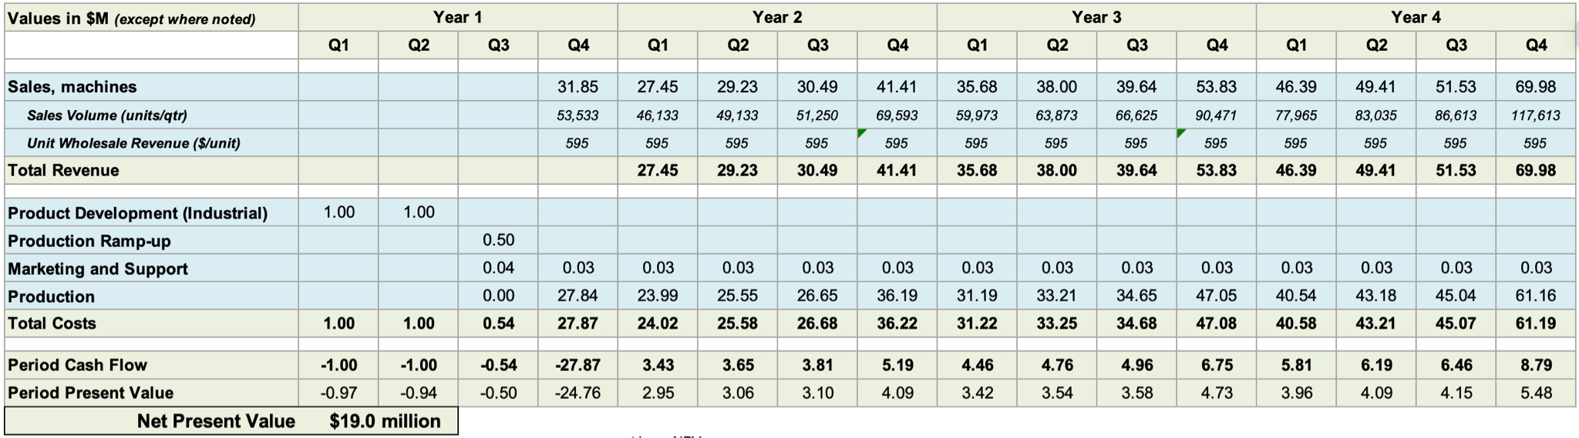

**Figure 8**: Model assumptions and parameters

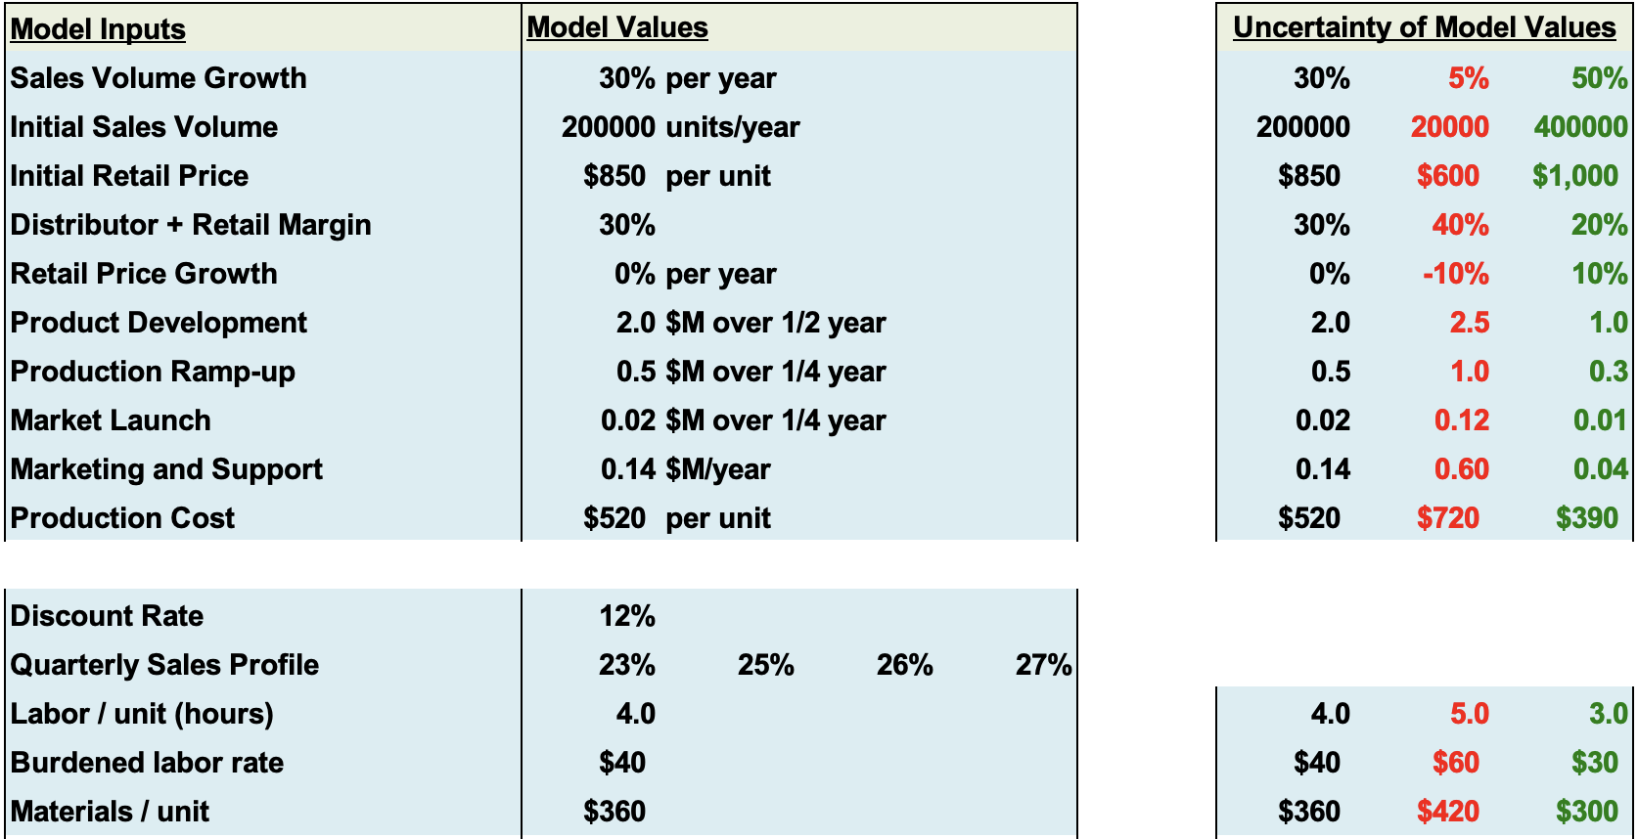

**Figure 9**: Tornado chart showing effect of parameter ranges on NPV

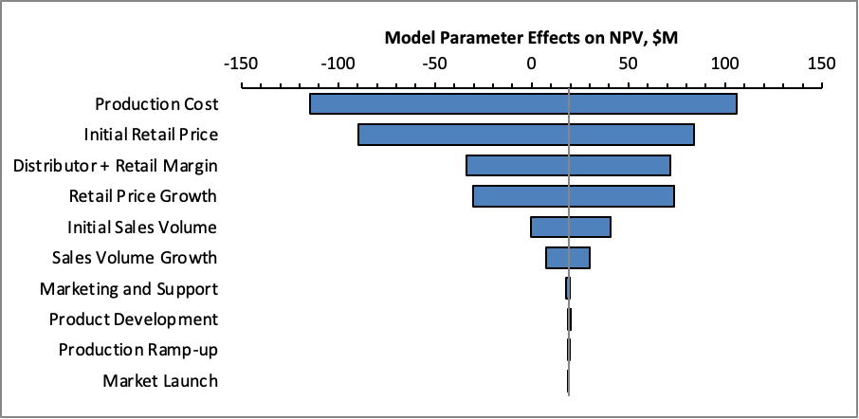

Qualitative analysis

Interactions with the 'firm':

* **Positive externalities**: A Grommet feature and interchangeable top opens the possibility of a new product line at no change to the existing bench. Lessons from designing the workbench can be applied to other products like a portable workbench.
* **Negative externalities**: Sturdiness and reliability of table reduces repeat purchase likelihood. Inventory space may be limited for prototypes and demo units, though this will be relieved somewhat by flat-packing).
* **Strategic fit**: The workbench has a strong strategic fit for the firm which is likely to center on a line of products for the at home maker. It will serve as a great flagship product with potential to establish a portfolio of accompanying products.

Interactions with the market:

* **Competitors**: A patent will provide some protection to our differentiation, but because of our material choices, the cost remains relatively high. This leaves us vulnerable to low-end disruption from lower-priced, lower-specification competitors.
* **Customers**: Relocating to larger work spaces (i.e. moving into a home or apartment with a dedicated maker room) may cause some customers to seek out other workbenches suited to a larger work area. Additionally the tendency for our customer to make, may lead them to follow one of the numerous workbench crafting tutorials online to build their own workbench.
* **Suppliers**: Our product is made primarily out of materials available consistently and in large supply such as hardwood and 16 gauge steel. Therefore there is not much concern of niche supplies having their cost be driven up.

Interactions with macro environment:

* **Economic shifts**: The recession triggered by the pandemic could lead to a downturn in the sales for our price range. However we hope this is offset by the upward trend in making and crafting during the pandemic.
* **Regulations**: The potential of tariffs such as the recent steel tariff could have negative impacts on our ability to manufacture the workbench in a cost efficient way.
* **Social trends**: The pandemic and subsequent lockdowns have led to an increase in at home making, which will drive up sales. Currently, we do not believe that trends towards environmentalism will affect the sales of our product.

# Next Steps

Going forward, we’ve identified 3 key areas for next steps. First, we would take the next few weeks to continue refining our testing and incorporating feedback from the final report assessment for a soft launch “Mini Makerspace.” Secondly, depending on the reception of our concept to a VC or Angel audience, we may want to pursue crowdfunding our investment for a soft launch as an option for initial funding. Lastly, we may pursue a patent based on our conversation with Bruce Sunstein, though there is still additional work to be done in ensuring that similar patents don’t exist.

# Retrospective and Team Management

Like the previous sprints, our team has been continuing with agile-style meetings--each led by a rotating scrum leader--comprised of “stand-up” check-ins as well as design, manufacturing, and business plan discussions. This worked well and will be continued until semester’s end.

Because the majority of the design brainstorming is complete, the Miro has been largely abandoned, replaced with an increased usage of Notion to organize the group’s next tasks by sprint and by member. Once everyone is on the same page in terms of our product direction and timeline, tasks are divided among members depending on their primary interests or expertise (i.e. building things, business finances, etc). Smaller sub teams have been formed, and the Slack channels feature has been exploited to facilitate scheduling and work updates between meetings.

Continuing to hold extra meetings that are set up through When2Meet has proven to be helpful, and WhatsApp still serves as a useful medium for immediate conversation between members on the days of group work. As a result, we have been able to avoid last-minute workload piles before deadlines and have been able to put forward the best current version of our product for demos, though this will get more difficult as the semester ends and other classes start demanding more time.

# Appendix A

**Table 5.** White Board Chemical Resistance

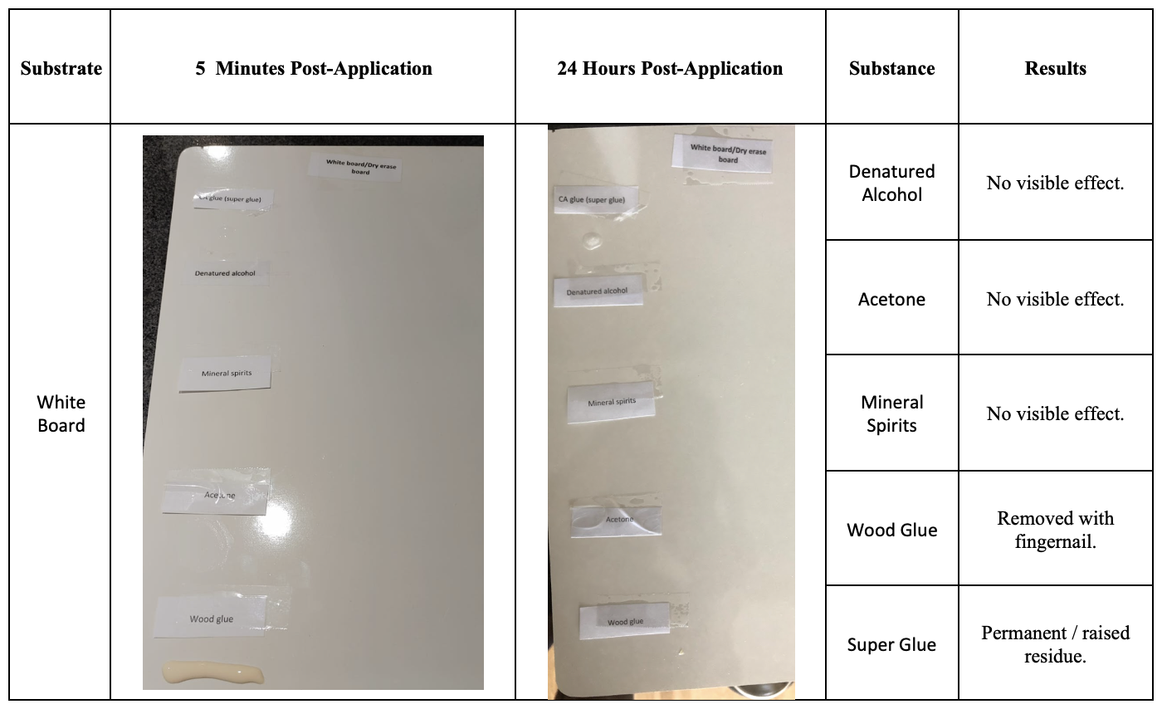

**Table 6.** Untreated Maple Chemical Resistance

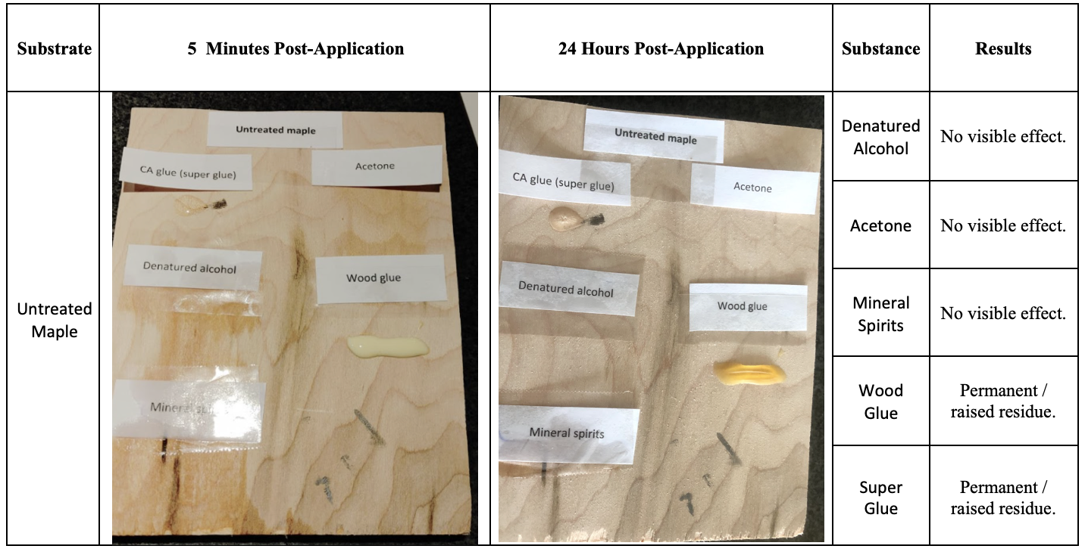

**Table 7.** Melamine Chemical Resistance

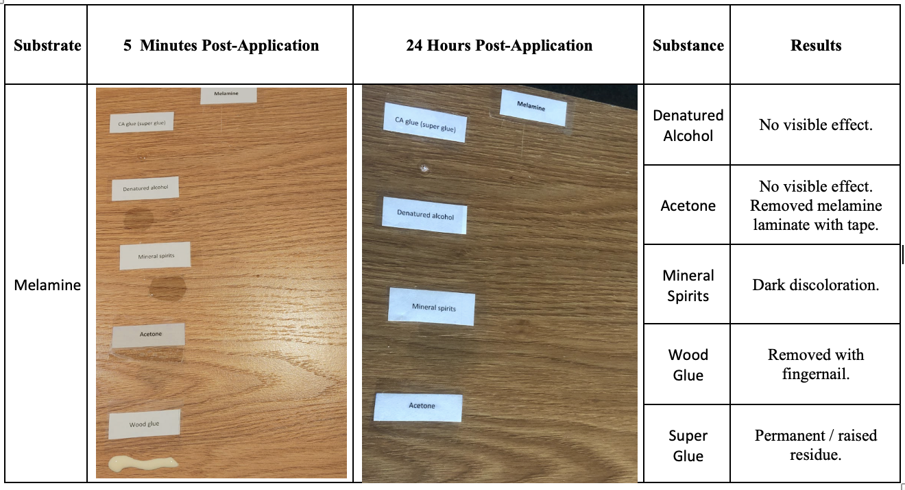**Table 8.** Self-Healing Mat Chemical Resistance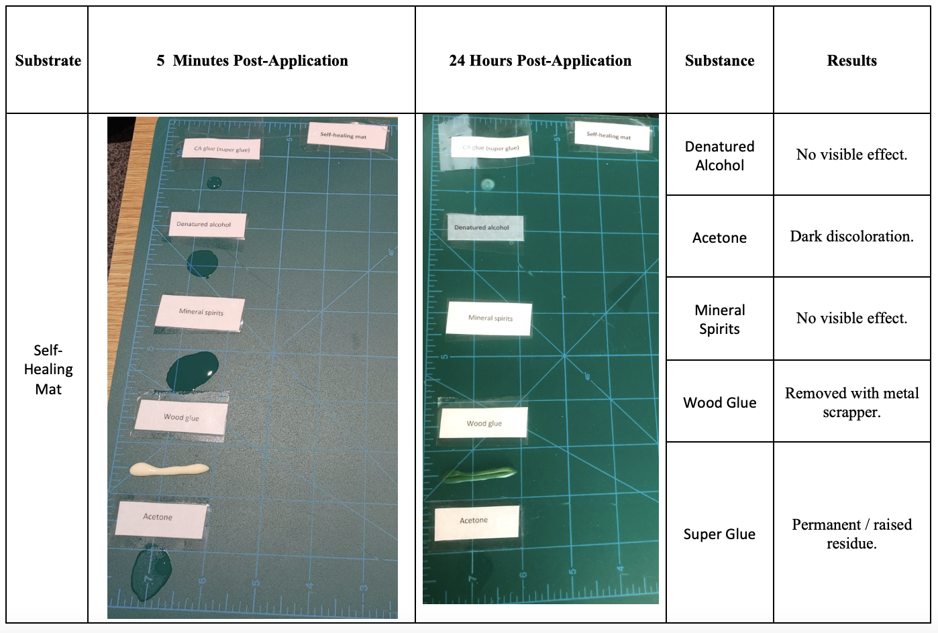

**Table 9.** Silicone Chemical Resistance

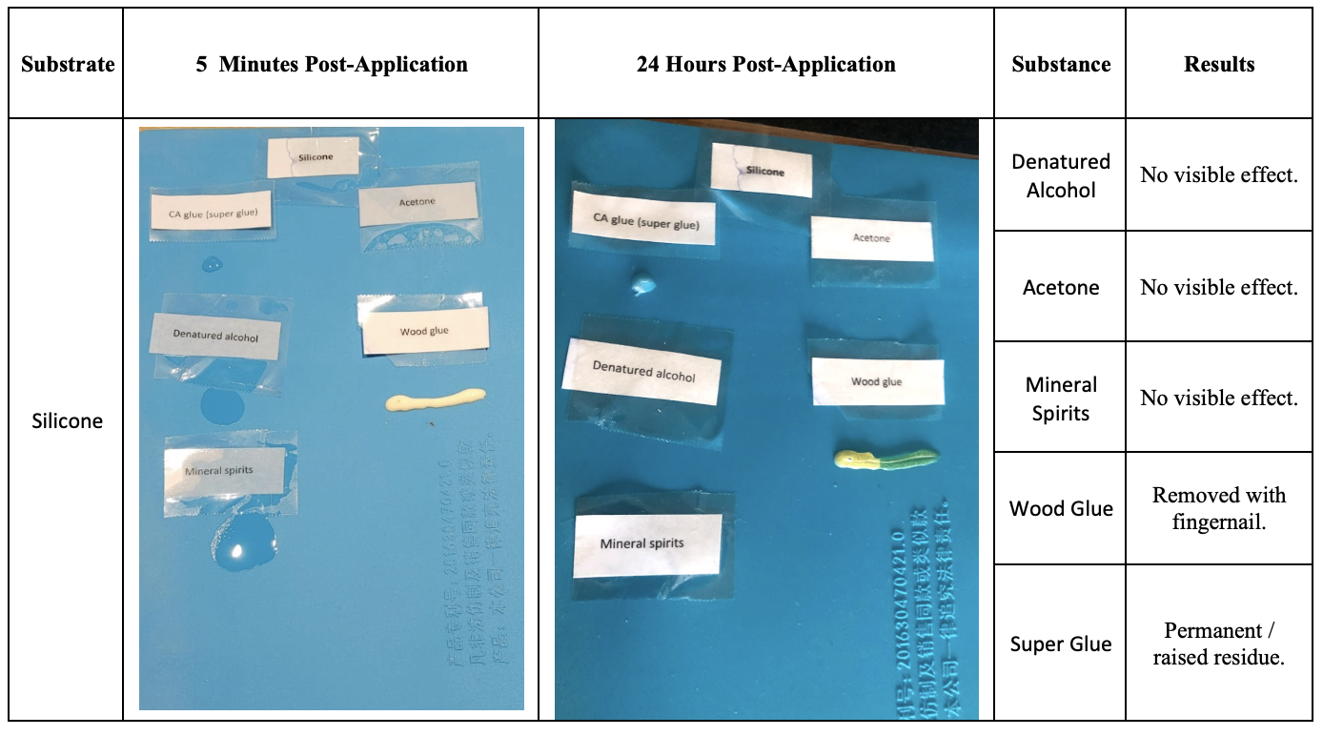

# Appendix B

**Figure 10.** “Wear and Tear” Test.

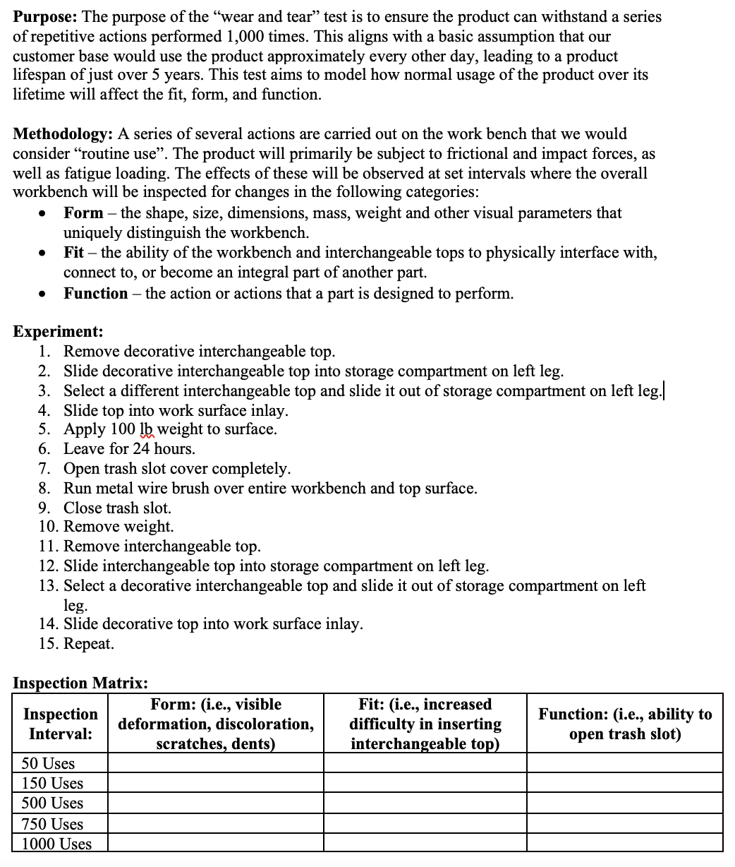

# Appendix C

Quantitative analysis

**Market Sizing:**

|  |  |
| --- | --- |
| **Total Addressable Market (TAM): *Total potential universe of customers*** | |
|  |  |
| 128.5M | Occupied apartments in US |
| 77% | Households with under 65s (most conservative number) |
| 98.9M |  |
| 44% | Apartments with >$75k household income |
| 43.5M |  |
| $800 | Our product price |
| **$34,815M** | **TAM (USA)** |
| **$45,260M** | **TAM (Global)** |
|  |  |
| **Serviceable Addressable Market (SAM): *Market that can be serviceable in the future*** | |
|  |  |
| 30% | Guess at maker-receptive people |
| 13.1M | Households with wealthy, young maker receptives |
| **$10,445M** | **SAM (USA)** |
| **$13,578M** | **SAM (Global)** |
|  |  |
| **Serviceable Obtainable Market (SOM): *What our company can achieve*** | |
| 30% | Near-term market penetration |
| 10 | Expected replacement rate (Years) |
| 0.39M | Desks we can sell |
| **$313M** | **SOM (USA)** |
| **$407M** | **SOM (Global)** |
|  |  |
| **30%** | **Scale for rest of world** |

# Appendix D

**Figure 10.** Finite Element Analysis of the workbench surface and left side leg

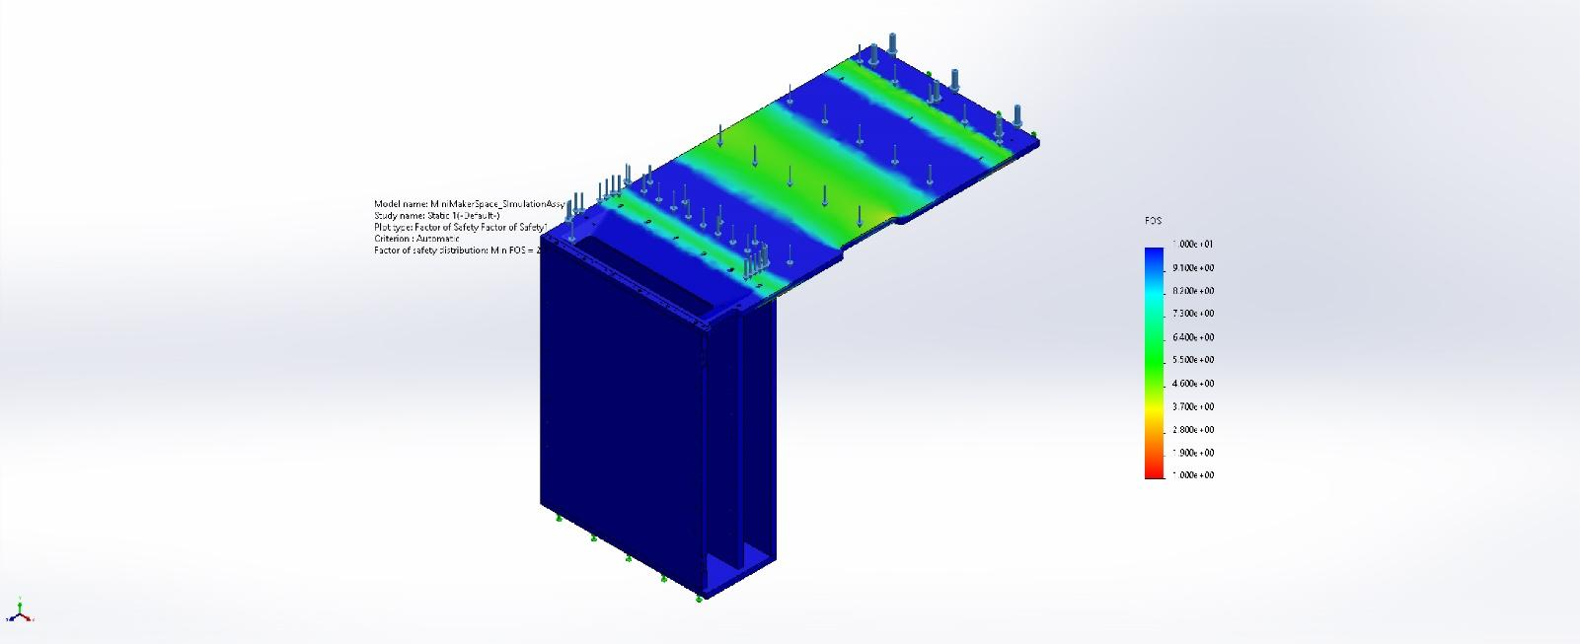

**Figure 11.** Finite Element Analysis of the right-side steel leg

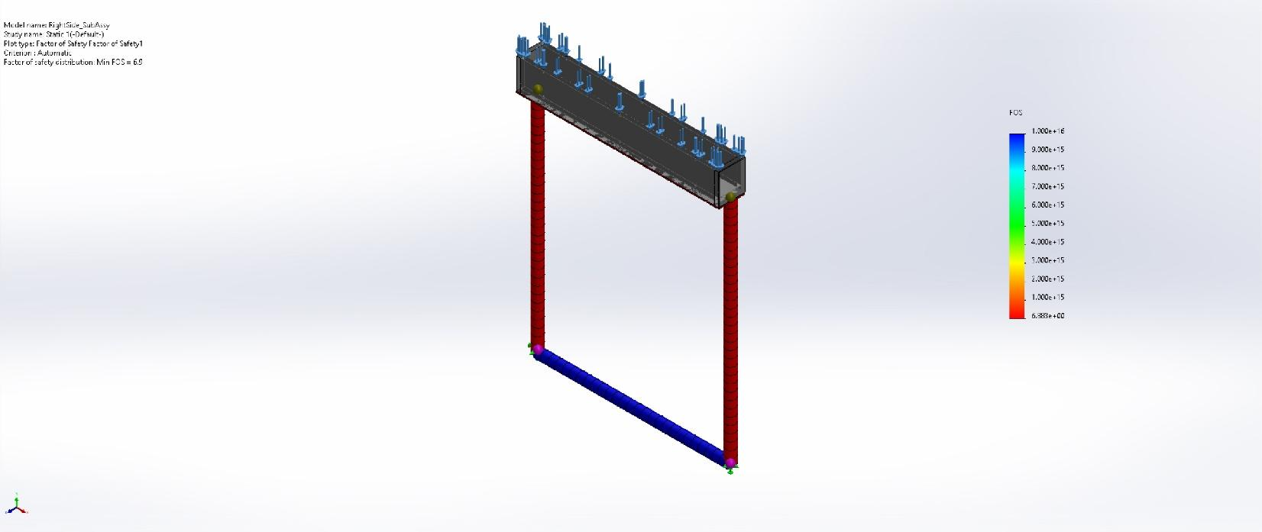

1. <https://patents.google.com/patent/US7036809B1/en?oq=7036809>
2. <https://patents.google.com/patent/US5722473A/en?oq=US5722473>